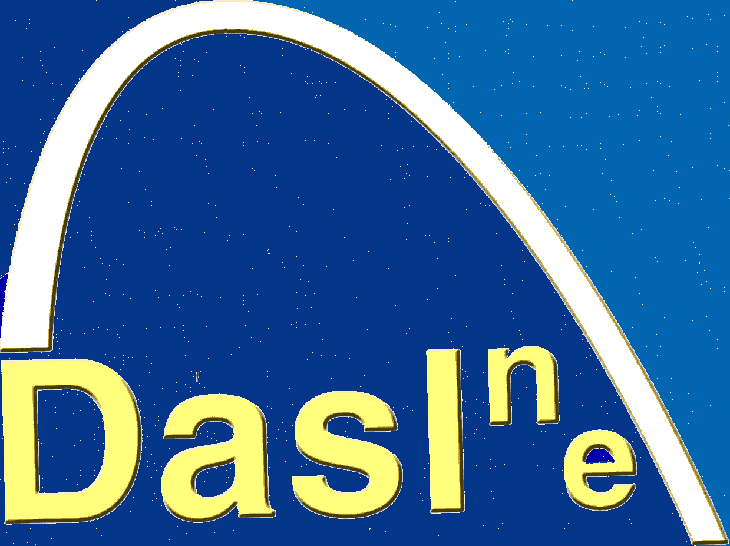

Why is the research being done?

With the new Autism Act (2010) there is a legal requirement for local authorities and health services to provide for the needs of adults with autism spectrum disorders. This survey is intended to inform the North East Regional Plan for Autism 2011, and the local plans for each authority. The survey has been commissioned by the North East Autism Consortium (NEAC: www.northeastautismconsortium.co.uk) whose role is to help develop the commissioning of services for adults with autism or ASD.

Dasl^{n}e and NEAC would like to know what help parents/carers think their young person with ASD will need over the next three years or so ie: what could professionals in education, social care, health services and voluntary organisations provide that would enable young people to achieve their goals?

What will the researchers be doing?

As part of this study the researcher will:-

- Use a survey to gather opinions from parents/carers of young people with ASD aged 16 years or above.
- Prepare a report for the North East Autism Consortium to inform the North East Region Plan for Autism 2011.
- Contact the same parents/carers again in three years time to compile a further report on improvements, if further funding is obtained.

How is Dasl^{n}e involved

Dasl^{n}e will contact parents of young people over the age of 16 on the database and invite them to complete and return the survey.

Who is funding the research

The research is funded by The North East Autism Consortium. Northumberland Tyne and Wear NHS Foundation Trust is the research sponsor for the Survey

Contact details:-

Professor Helen McConachie, Director of Dasl^{n}e 0191 282 1396 (Email:

H.R.McConachie@newcastle.ac.uk

Mary Johnson, Coordinator of Dasl^{n}e, 0191 282 1400 (Email: m.johnson@newcastle.ac.uk).

